Name:_______________
Date:________________

Ancient Egyptian Geography

Economics | The _________________,________________, and _________________
 | Of ___________and _______________.
The Nile River | The world’s ________________ river. It begins along the _____________
 | And flows _______________. Near the sea, the Nile branches out into a
 | _____________. The Nile is _________ miles long! It is the __________
 | River in the world.
Delta | An area near a ________________ mouth that _______ fine _________
 | Called _________________. The ______________ divides into many
 | ___________________!
The Flow of the Nile | The Nile River flows from _____________ to _______________. It
 | Empties out into the _____________________ Sea.
 | It rains _________. The Nile ______________ every summer. This is
 | Great for farmers because they are ____________ ________________.
 | The flooding _______________ fine soil.
Linen | The Egyptians made __________________. They weaved ___________
 | From plants to create __________________.
Desert | The geography of Egypt had many ____________. These were very hot
 | And _________ areas of land. They were good because they provided
 | _______________ against __________________.
Shadoof | Used by _________ to move water between the ________ and the _____
 | It _________ Egyptian’s ability to use _______ efficiently.
Practice Questions:

1. Define economics:

2. What benefit does the landscape and climate of a desert give to people living near it?
a. flat land for road building
b. mineral wealth
c. fertile soil
d. a barrier to invasion

3. Which way does the Nile River flow?

4. Label: which river valley is Mesopotamia, and which is Egypt
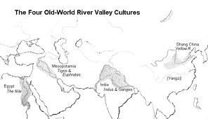

5. Which on the map is the Nile River Valley and which is the Mesopotamia River Valley?
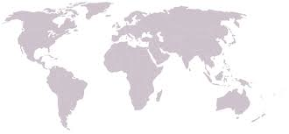

Mesopotamia vs. Egypt – Test your skills!

Rivers in Ancient Mesopotamia | Rivers in Ancient Egypt

Climate in Ancient Mesopotamia | Climate in Ancient Egypt

Continent Ancient Mesopotamia is in | Continent Ancient Egypt is in

True or False: Circle either T/F – Circle T if it is true and F if it is false
1. Both the Tigris, and the Nile flooded. T/F
2. In both Egypt and Mesopotamia the floods brought good things like silt or fine soil T/F
3. Farming was the main source of food in Ancient Egypt and Mesopotamia T/F
4. The Nile River flows from North to South T/F
5. The Nile River is in Asia T/F

